# Brightcove technical exercise

## TSR Operations Support – API & Development Skills Assessment

By: Paulina Arvizu

To run the code, once you have downloaded the files you will need to run these commands in the terminal:

npm init --yes

npm i express

npm i nodemon

npm install xmlhttprequest --save

Then, run the nodemon server.js –ext js command to start the code.

If you want to re-write the data int the data files, follow the next steps. In server.js, uncomment line 41, and in line 40 you will need to enter an access token. This token can be requested by entering your client credentials in the following link.

<https://apis.support.brightcove.com/oauth/code-samples/oauth-api-sample-get-access-token.html>

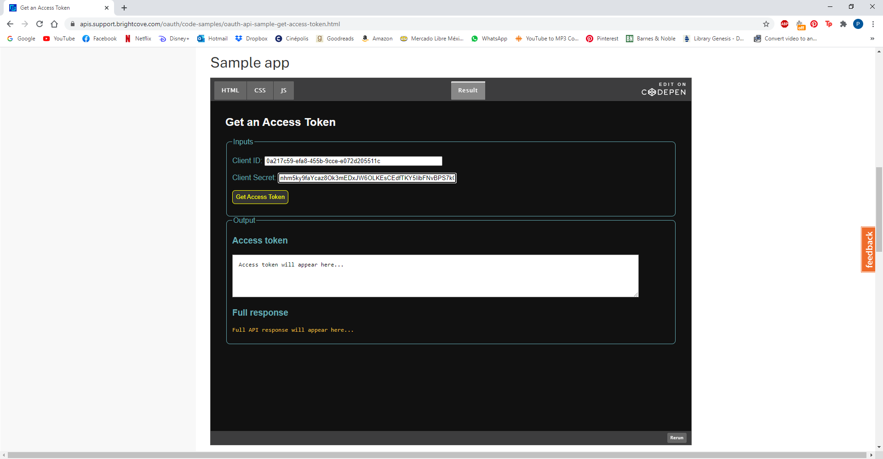

server.js:



In your browser, go to localhost:3000.

The /info endpoint shows all the stored information. If the *Only “mexico” tag* checkbox is checked, it will show the total video duration only for the videos with the tag “mexico.”

